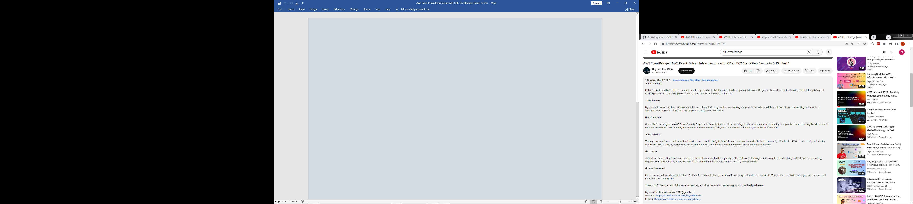

We will use EventBridge to capture events and act on it

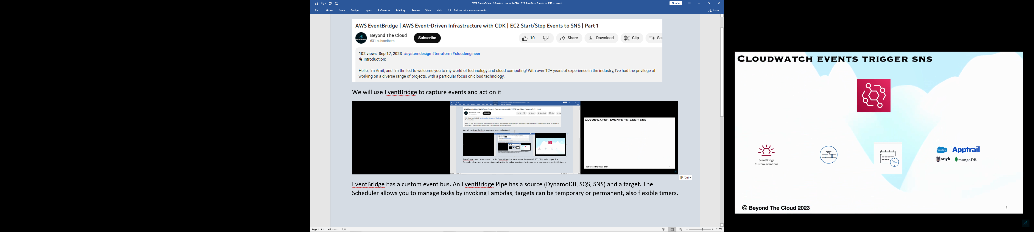

**EventBridge** has a custom event bus. An EventBridge **Pipe** has a **source** (DynamoDB, SQS, SNS) and a **target**. The Scheduler allows you to manage tasks by invoking Lambdas, targets can be temporary or permanent, also flexible timers.

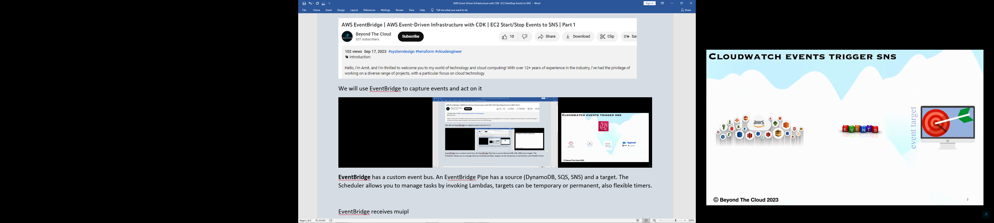

**EventBridge** receives multiple events from several sources, does some processing, and posts to some sinks.

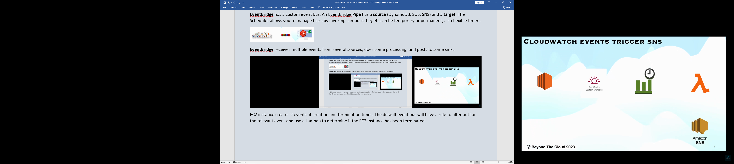

EC2 instance creates 2 events at creation and termination times. The default Event Bus will have a rule to filter out for the relevant event and use a Lambda to determine if the EC2 instance has been terminated. The Lambda will then send out an email with the result about the EC2 instance.

